IMRT planning with Corvus 6.2 vs. Pinnacle 7.4f
Nathan Childress, Ph.D.

Summary
We are currently using Corvus 6.2 and are investigating whether to move to another TPS for IMRT plans, due to Corvus’ network problems. Pinnacle 7.4f generated very comparable plans when optimizing using the same dose constraints and beam angles. Neither planning system produced results clearly superior to the other. However, Corvus plans used 2-3 times more MUs and resulted in delivery times about twice as long as Pinnacle for both simple and complex cases. It is reasonable to expect better IMRT QA results with Pinnacle due to its convolution-superposition algorithm, MLC leakage modeling, head scatter modeling, and computation of deliverable fluence. There were no other significant differences between the two systems. Moving to Pinnacle IMRT will require dosimetrist training and supervision, but will result in shorter delivery times and fewer planning systems in our department.

Features
Both systems are fairly easy to use and are matured products. Corvus requires the user to follow a step-by-step process (image registration, fusion, anatomy, prescription…) and resets the information in all later steps if the user goes back and changes an earlier step. Pinnacle is more free-form, allowing users to edit whatever they want whenever they want. It also has more options in nearly every category, making it a much more flexible tool that requires more training.

Corvus dose calculations rely on optimum fluence maps, and multiple assumptions built into the dose calculation and MLC segmentation algorithms designed to balance each other out. This results in reasonable dose calculations for the “average” IMRT plan, but these assumptions fail for lightly and heavily modulated beams. I have seen erratic Corvus QA behavior in our clinic, and with ~1,000 Corvus MLC IMRT QAs that I observed at MD Anderson.

Pinnacle uses superior dose calculation algorithms. Not only does it calculate deliverable fluence, but with the DMPO package it optimizes MLC segments directly. Combined with its hybrid convolution-FSPB algorithm, its optimization calculations very closely match the final dose computation with the full convolution-superposition algorithm. Users can control the total number of segments in the plan, as well as add static beams (e.g., superclav fields) that are not optimized.

Ease of use
Our dosimetrists are all familiar with Pinnacle. The IMRT module is very simple to use when purchased with DMPO. Dosimetrists may need to change the number of segments for each plan. A typical plan would use 10-20 segments per beam. In Corvus, all structures are assigned a structure type, a DVH point, and min / max doses. In Pinnacle, users may enter as few or as many dose objectives as they wish. This results in greater control over the final plan, but more choices for the user. After the first Pinnacle optimization has occurred, users typically must contour hot spots and reoptimize to get them to go away.

Planning Speed
Corvus plans take 20-45 minutes to optimize and compute dose, while Pinnacle plans take 8 minutes to 2 hours. Times to optimize Pinnacle plans are very dependent on the number of beams, whether the fields were split, and complexity of the plan. Both planning systems could be upgraded to result in slightly shorter calculation times.

Patient results
Unless otherwise stated, all Corvus plans were run using a 0.5x0.5 cm² fluence grid. Moving to a 0.5x1.0 cm² fluence grid may reduce the MUs by half and result in comparable plans. Corvus segments are generally modeled after sliding window deliveries, even in step and shoot mode, and use small openings that are delivered faster than Pinnacle segments. Pinnacle segments have large openings with large MLC movements between each segment, thus requiring fewer MU.

Corvus tends to produce conformal plans with a large spread in tumor dose. Pinnacle requires ring structures and other imaginary control structures to be optimized in order to produce a conformal dose, but has excellent target dose homogeneity with the “Uniform dose” objective.

Both Corvus and Pinnacle plans could be improved. I used clinical Corvus plans, and transferred CT and ROI data to Pinnacle. I generally used the objectives entered into Corvus, whether or not they were realistic. I did not spend a lot of time on each Pinnacle plan. I never contoured hot spots and reoptimized. I did use ring structures to improve conformality. The mean tumor dose was almost identical for all cases, meaning that neither system was beating the other in terms of total body dose. Basically, you can change objectives in either system and move dose around to different spots, but neither system will result in removing dose. This is a good sign, meaning both systems result in fairly optimum plans. Or they’re both really bad, but the same magnitude of really bad.

Pinnacle fared well with dumb objectives. Time after time, if you put the same objectives, beam angles, etc. into both systems, you would get nearly identical DVHs. In general, OAR doses were slightly lower in Corvus, and target uniformity was greater in Pinnacle. In general, I think our dosimetrists could get good plans using the same objectives they’re used to, followed by contouring and iterating 10 more times to remove hot spots.

Pinnacle will definitely have a learning curve. My main goal was to get a general feel for Pinnacle, and see if inexperienced idiots can get decent plans. Pinnacle did work well, but I can definitely see how more experience with objectives and imaginary dose constraint OARs will improve plans and reduce the planning time.
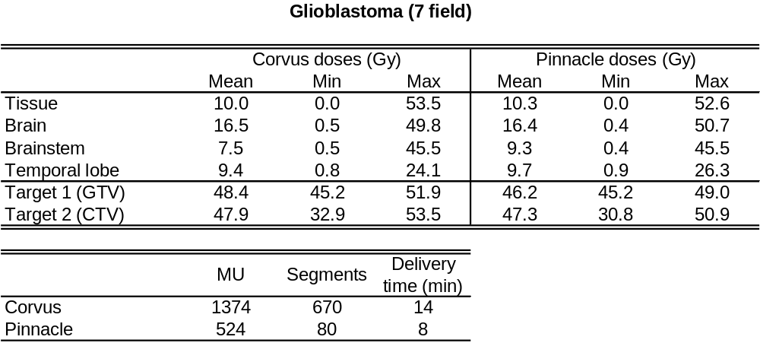

Notes: This was simple, large, glioblastoma. No real critical structures, so a spherical conformal dose was required. The CTV was near the skin surface, hence the low min dose.

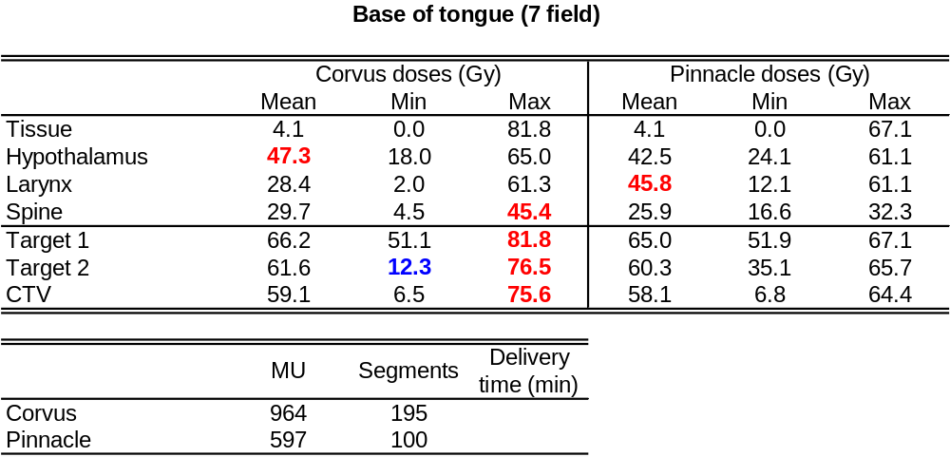

Notes: Small target, Corvus could not reduce the cord dose, even though it was several cm away. Pinnacle put more dose into the larynx. The cord objective could be loosened on Pinnacle so the hot areas could be moved around, if the physician wanted.

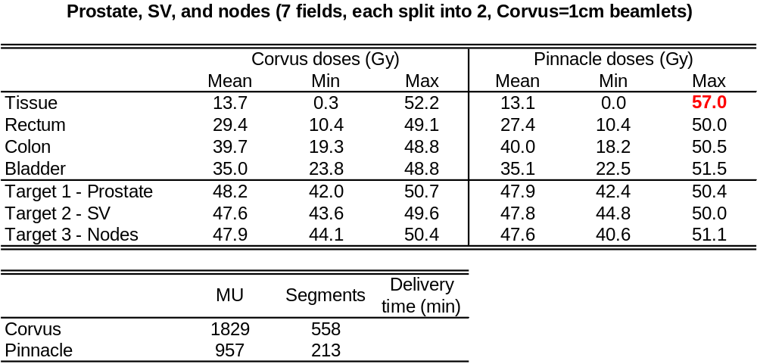

Notes: This plan was optimized by Dr. Grant, using the 1 cm mode of Corvus. It is a very difficult plan. Even with the 1 cm mode, Pinnacle still uses half of Corvus’ MUs. Pinnacle likes to put hot spots in normal tissue that doesn’t have constraints, so this is a good example of a difficult case that would result in contouring fictitious structures to get Pinnacle to reduce its hot spots.

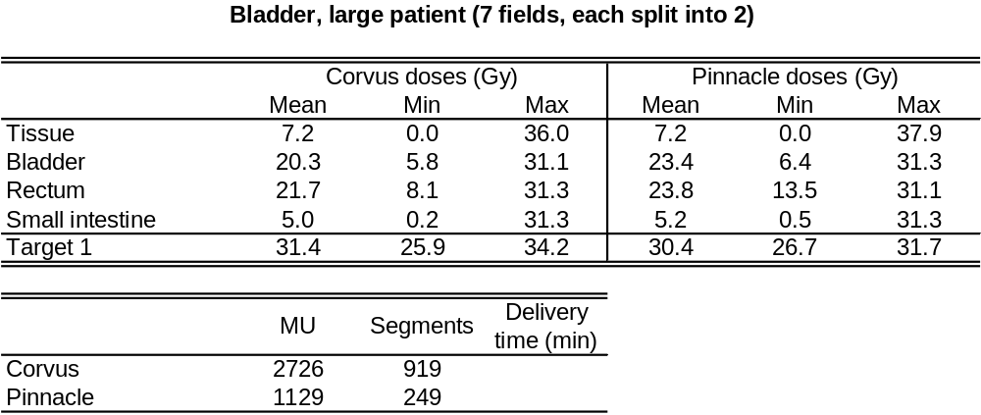

Notes: This was a very large patient. Dosimetrists hacked away at Corvus for 2 days. This was my first try in Pinnacle. Hot spots are outside the target due to the patient’s size. Pinnacle has superior target uniformity and hotter spots outside the target that may need to be contoured and reoptimized.

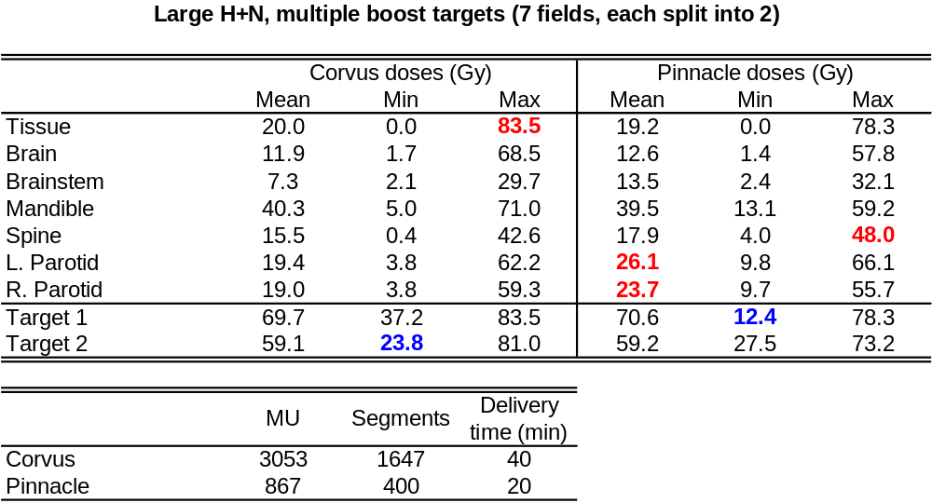

Notes: This plan was absolutely insane. It was the first one I optimized in Pinnacle. Huge targets, extending all the way to the skin surface (hence the low target min doses), with several large and small boost targets (nodes? places the physician felt frisky?) throughout. I hacked away at Pinnacle for a few days to get this plan. Using minimum and maximum target objectives worked better than “uniform dose” in Pinnacle, as a large spread in dose is needed to achieve any reasonable plan. Again, the small hot spot in the spine could be separately contoured and reoptimzed. No matter what I tried, I could not significantly reduce Pinnacle’s parotid dose, which was abutting the tumor. The isodose lines were very conformal to the target, but Pinnacle’s dose was always higher (how much would parotid doses change if Corvus used Pinnacle’s calculation algorithm?).

Printout documentation
Both Corvus and Pinnacle allow the user to create custom reports. We use a basic treatment delivery report and multiple screen captures to document Corvus plans. Pinnacle also has its standard report with beams and ROI doses, and an IMRT report that does a good job of succinctly showing all planning objectives, optimizer values, and deliverable fluence maps. Users must print a screenshot of DVHs. Both systems have good printout documentation.

QA
Corvus film QA results seem to be erratic. BrainLAB film QA results, which use the same phantom geometry, are much more predictable and agree better with calculations. One composite (7 fields delivered to EDR2 film in a coronal plane) film and one single-beam (1 IMRT field delivered at 0° gantry angle) film were analyzed from Pinnacle plans. This is clearly short of what would be required for full commissioning, but was useful to see if there were any large errors and compare the QA tools.

Pinnacle’s QA tools are all built into the main user interface, so no command line scripts have to be written to extract dose planes. They allow single beam calculations on a water phantom, as well as extraction of a composite dose plane in a phantom or patient.

Both Pinnacle QAs agreed well with calculations. The composite plan had an overall dose normalization of 1.025, and agreed well both in high and low dose areas. Corvus tends to have problems in low dose areas, which has often been blamed on possible film calibration errors.

Pinnacle profile, note the penumbra and tail agreement
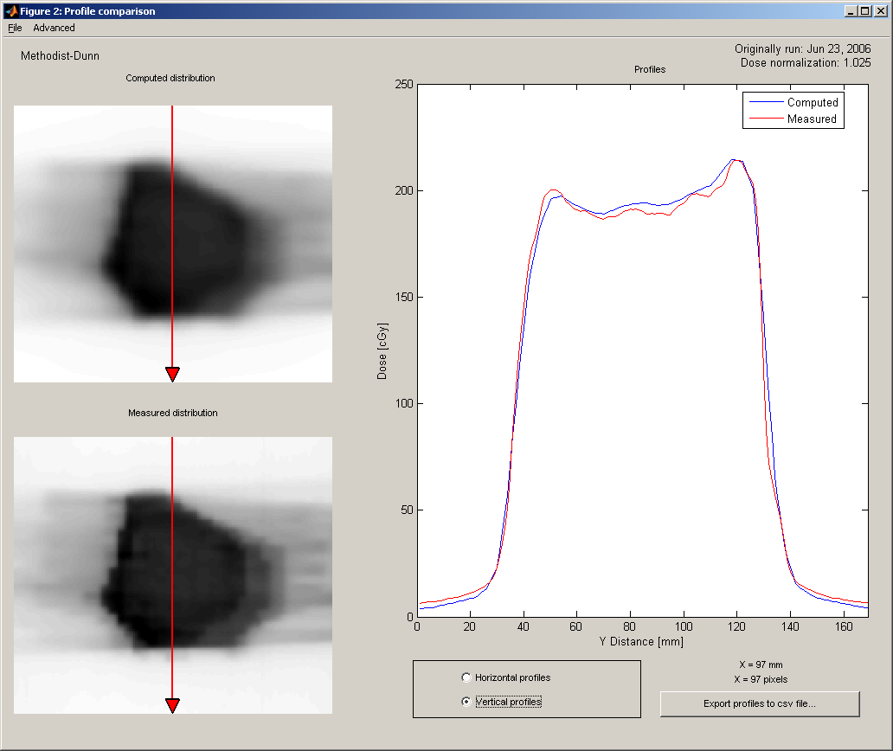

Corvus profile from the same patient
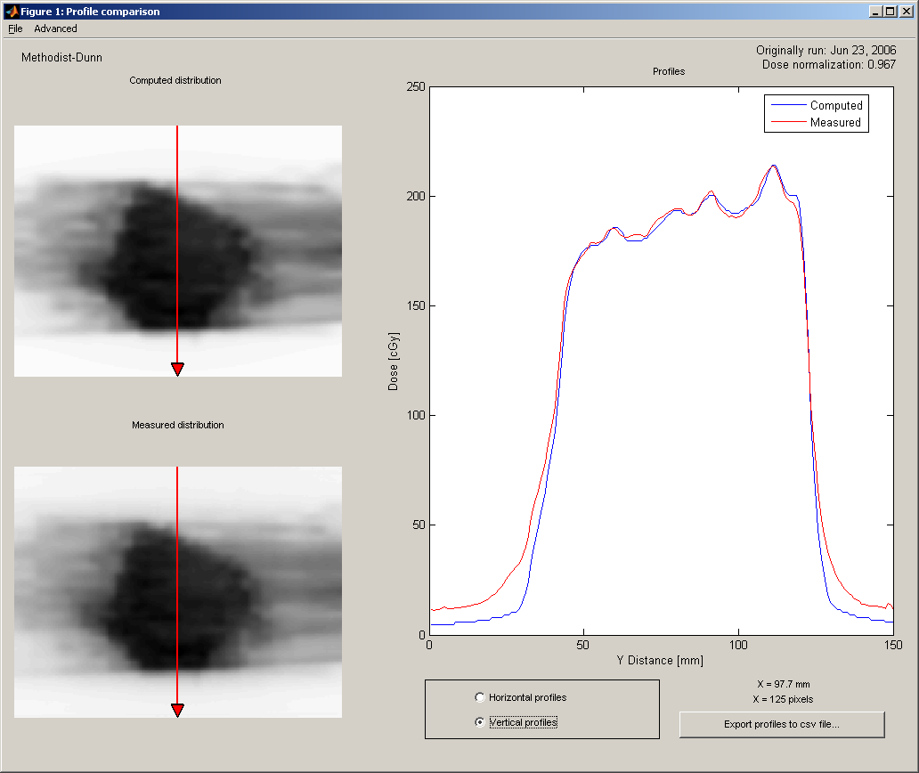

Even from the black and white images of the films it’s easy to notice that Corvus performs much more modulation to obtain similar conformality. The tail agreement on the Corvus QA is precisely why I question Corvus’ true parotid dose, as the parotids on that patient were along the edge of the heavily modulated target. This behavior can be seen in nearly all Corvus verifications.

Pinnacle on left, Corvus on right
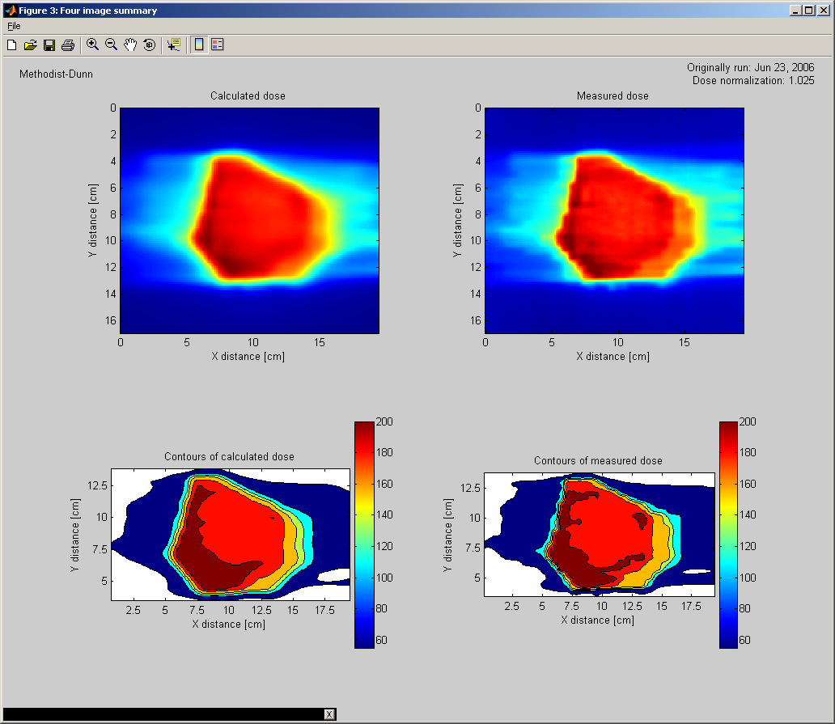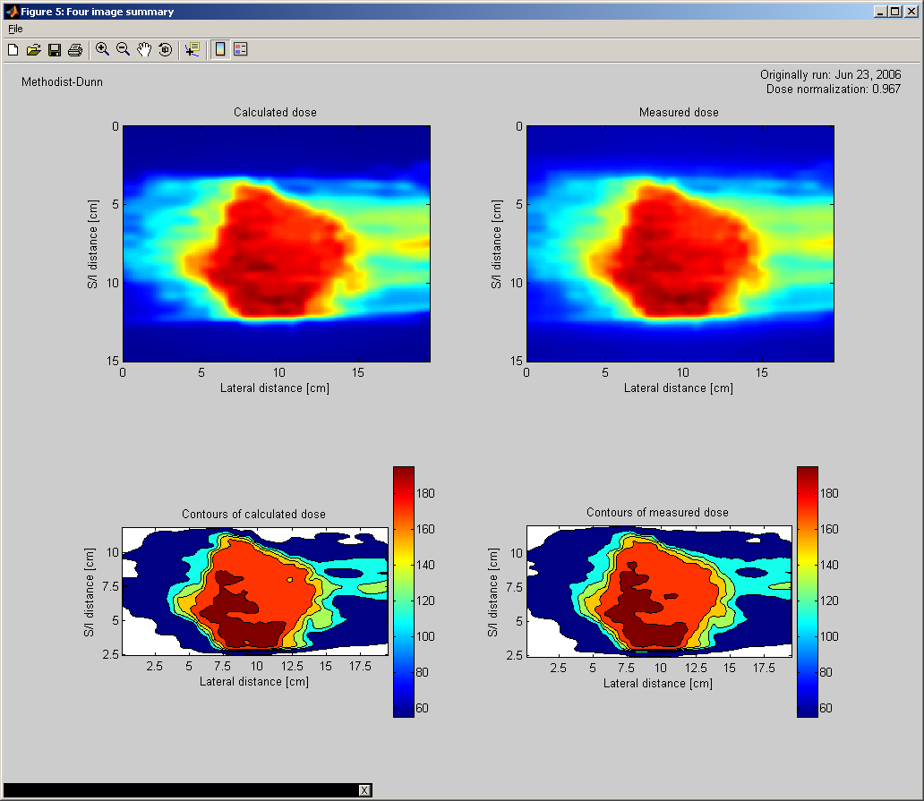
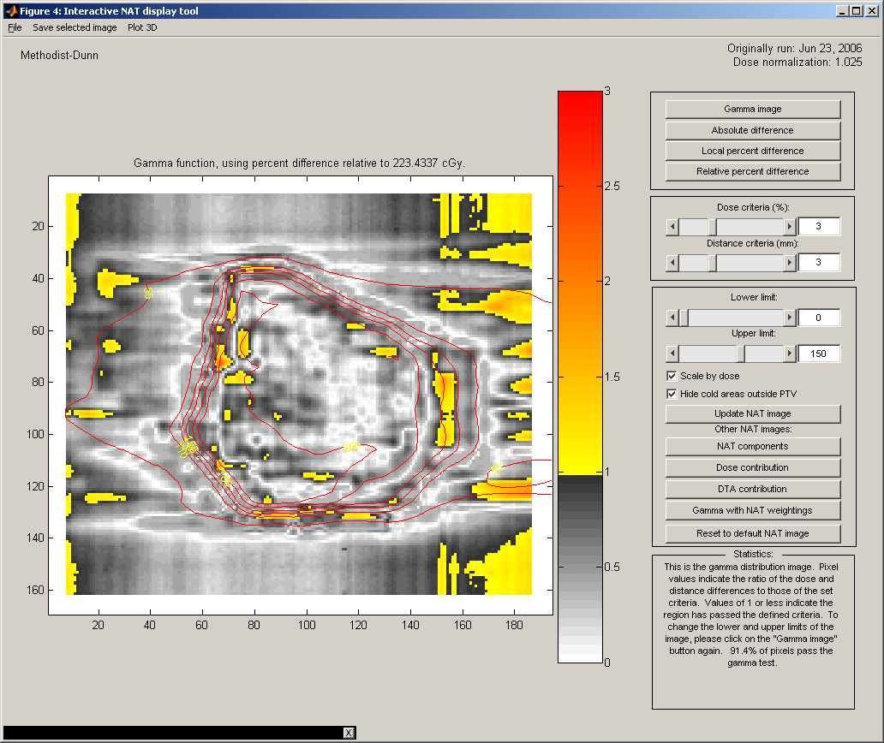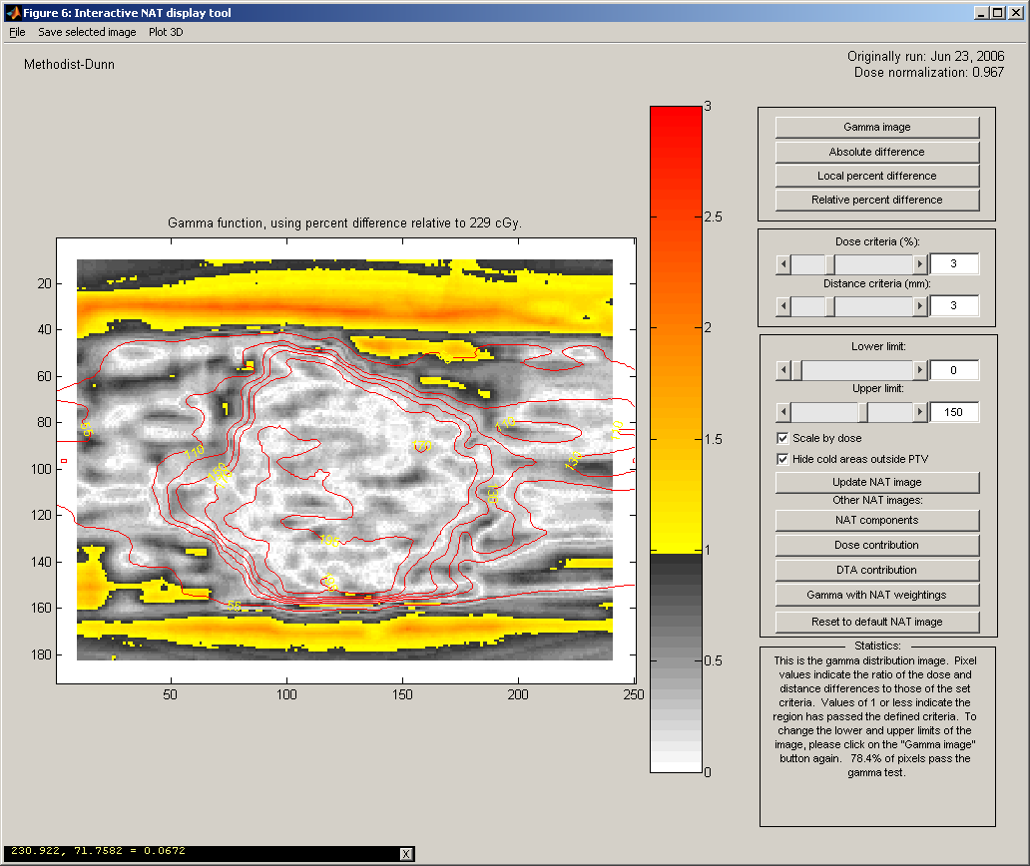

The single-field verification had a normalization of 1.016, and also had excellent agreement in high and low dose areas.

Pinnacle single-field verification
